GAMBLE GARDEN
COOL TREE TOUR FOR FAMILIES
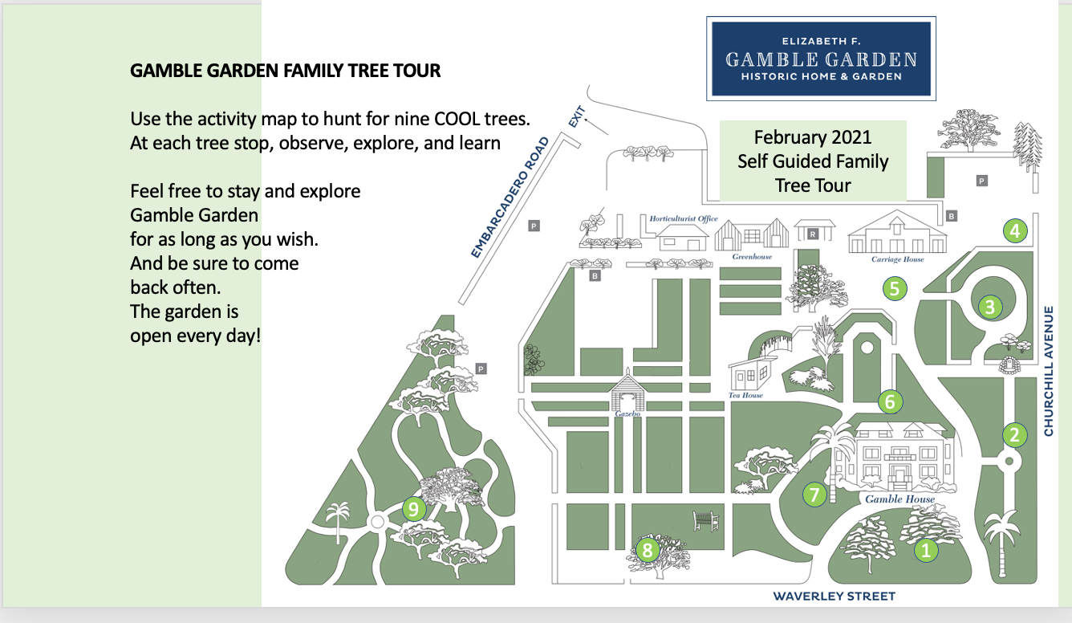
Cool Tree #1 MAGNOLIA

COOL FACT: Our pair of southern magnolia trees have large, white, fragrant flowers which bloom in late spring and summer. Scientists think they resemble the first flowers to ever evolve on earth.

ACTIVITY: Look on the ground for magnolia “seed houses.”
Pick one and use three of your senses to explore it – seeing, feeling, smelling. What do you observe? Do you see where magnolia seeds come from?

BONUS ACTIVITY: Write some notes about what the magnolia’s leaf and bark remind you of. Use your notes to compare with the leaves and bark of the other eight trees.

Cool Tree #2 CRABAPPLE

COOL FACT: A crabapple is any apple tree whose apples grow to less than 2 inches in diameter. People call them miniature apples.

ACTIVITY: Count how many crabapple trees there are here and describe how they are arranged. We call this arrangement of trees an “allée” (rhymes with ballet.) An allée has focal points. How many focal points does this allée have and what are they?

Cool Tree #3 TREE ROSE

COOL FACT: Tree roses are not really trees, but they have been pruned by gardeners to resemble a tree. Roses have thorns on their stems to protect themselves from hungry deer and other animals.

ACTIVITY: Draw a picture of a tree rose with you touching a thorn.

Cool Tree #4 REDWOOD

COOL FACT: Redwoods are the tallest trees on earth. In fact, they are the tallest living things on earth. A redwood tree can grow to be over 300 feet tall.

ACTIVITY: Look up, can you see the top? Look down, can you see the redwood leaves covering the ground? How are they different from the leaves of the magnolia tree?
Feel and study the bark – how can you use the bark to help you remember the redwood tree?

BONUS ACTIVITY: You can get an idea of how long 300 feet is by placing a marker and taking 150 steps in a straight line from your marker. After 150 steps, look back to your marker – that is how long a redwood would be if it were lying on the ground. A good place to try this is on the sidewalk along Churchill right next to the redwood trees.

Cool Tree #5 SHUMARD OAK

COOL FACT: This type of oak is native to the southeastern part of the United States, far away from California. Why is this a nice tree to have on the patio? What can we thank this tree for?

ACTIVITY: some trees are evergreen, and their green leaves grow on their branches all year long. Other trees are deciduous, and they drop all their leaves for winter. After a tree drops its leaves, we say the tree is bare. Use your powers of observation to infer – is the Shumard oak an evergreen tree or a deciduous tree? How did you decide?

BONUS ACTIVITY: Draw or trace a Shumard oak leaf.

Cool Tree #6 PAPERBARK MAPLE

COOL FACT: This tree comes from Japan and has very interesting bark. Like all maples, this tree likes to grow in shady places.

ACTIVITY: Find a place nearby where you can stand in the shade then jump into the sun and jump back into the shade.
If you were a tree, would you want to live in a sunny or shady place? Why?

BONUS ACTIVITY: Find and explore the water feature in this garden room.

Cool Tree #7 PALM TREE

COOL FACT: This tree comes from the Canary Islands – 8 islands in the Atlantic Ocean off the coast of Africa. Each of the palm’s leaves are many feet long – some are up to 15 feet long. They are called fronds. A palm tree does not have branches – instead the leaves grow out of the top of the trunk or stem.

ACTIVITY: Find the hole in the trunk about 2/3 of the way to the top of the tree –
What kind of animal do you think uses the hole? How does it get there?

BONUS ACTIVITY: Draw a palm tree and add yourself to the picture.

Cool Tree #8 LIVE COAST OAK

COOL FACT: This tree grows wild in California where summers are dry and winters are rainy.

ACTIVITY: Find an oak leaf that has fallen to the ground. Make a guess about how the leaf’s shape and thickness help the oak to withstand long periods with no rain. Can you find acorns on the ground? Draw an acorn or a live oak leaf.

Cool Tree #9 EUCALYPTUS

COOL FACT: The eucalyptus tree evolved in Australia along with koalas, who live most of their lives eating and sleeping up in a eucalyptus. Eucalyptus trees are the tallest flowering trees (Redwoods have cones, not flowers.)

ACTIVITY: With your family, try to link hands around the base of this tree to see if
you can reach all the way around.

BONUS ACTIVITY: Find the water fountain and stone garden stools in the watershed garden behind the eucalyptus.

WE HOPE YOU HAD FUN AND LEARNED A LOT ON GAMBLE GARDEN’S COOL TREE TOUR!
IF YOU WANT TO SHARE YOUR NOTES OR DRAWINGS WITH US, PLEASE SEND A PHOTO OF THEM TO GARDENGUIDES@GAMBLEGARDEN.ORG.

